

CSA0501-DATABASE MANAGEMENT SYSTEMS

LAB EXPERIMENTS DATE: /08/2026

EXPERIMENT 17– HIGH LEVEL PROGRAMMING EXTENSIONS – FUNCTIONS
AIM: To implement functions using programs in MySQL.

PROCEDURE:
- Select the pet_management database.
- Create a user-defined function using CREATE FUNCTION.
- Use the IF statement to determine the pet level based on total.
- Execute the function using the SELECT statement.
- Create a recursive procedure to calculate the factorial of a number.
- Execute the recursive procedure by passing a number.
- Verify the output successfully.
PROGRAM:

FUNCTION:

We'll classify the pet based on total:

total > 6 → HIGH

total >= 3 → MEDIUM

total < 3 → LOW

DELIMITER //

CREATE FUNCTION pet_level(p_total INT)

RETURNS VARCHAR(20)

DETERMINISTIC

BEGIN

DECLARE level_name VARCHAR(20);

IF p_total > 6 THEN

SET level_name = 'HIGH';

ELSEIF p_total >= 3 THEN

SET level_name = 'MEDIUM';

ELSE

SET level_name = 'LOW';

END IF;

RETURN level_name;

END //

DELIMITER ;
OUTPUT:

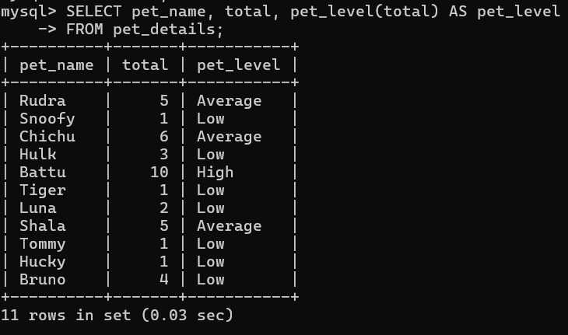
- RECURSIVE PROCEDURE:
Create Recursive Procedure for Factorial
DELIMITER //

CREATE PROCEDURE factorial(IN n INT, OUT result INT)
BEGIN
IF n <= 1 THEN
SET result = 1;
ELSE
CALL factorial(n - 1, result);
SET result = n * result;
END IF;
END //

DELIMITER ;
OUTPUT:

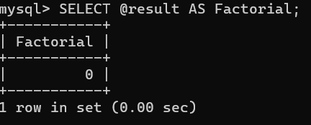

RESULT: The user-defined function and recursive procedure were successfully implemented in MySQL. The required outputs were obtained correctly..

